Section I. - 75 marks

Part A : Multiple Choice questions - 15 marks

Attempt all Questions (1. to 15. 1 mark each)
Allow about 30 minutes to complete this Part.

Use the Multiple Choice Answer sheet provided.

Select the alternative A, B, C or D, that best answers the question and indicate your choice by clearly marking your answer in the appropriate place on the Answer sheet.

1. Which of the following shows what happens to the high molecular weight
fractions in crude oil during the process of Catalytic cracking?

(A) They combine to form higher molecular weight compounds.

(B) They add together without loss of electrons.

(C) They break down into lower molecular weight compounds

(D) They form by the elimination of a small molecule.

2. Which of the following is the IUPAC systematic name for the compound whose
structure is given below?

Br Br
׀ ׀
CH₃ − CH₂ – CH₂ – CH − CH₂

(A) 1,2 – bromopentane

(B) 1,2 - dibromopentane

(C) 4,5 - dibromopentane

(D) 4,5 - bromopentane

3. Propanol and acetic acid are refluxed together in the presence of a small
amount of concentrated sulfuric acid. This reaction is an example of

(A) Hydrolysis

(B) Acidification

(C) Esterification

(D) Hydrogenation

4. Which of the following shows a process where Ethanol can be formed from
ethane?

(A) Fermentation of sugars with a yeast catalyst.

(B) Removal of water with a concentrated sulfuric acid catalyst.

(C) Fermentation of biomass material with an enzyme catalyst.

(D) Addition of water with a dilute sulfuric acid catalyst.

5. A scientist was analysing a sample of air and found the following gases present, with
their respective proportions.

Gas | Content level  (parts per million)
Carbon dioxide  Carbon monoxide  Sulfur dioxide  Nitrogen dioxide | 308  0.4  2.0  0.001

Which of the following is most likely to be where the air sample was collected?

(A) over a factory site

(B) in a car park

(C) in a mine

(D) near a rural village

6. The volume of hydrogen gas that forms (at 0°C and 100 kPa), when 1.0 g of
magnesium reacts with excess hydrochloric acid is

- 1.01 L
- 0.93 L
- 0.50 L
- 0.46 L

7. Styrene is commonly used to produce foam packaging and drinking cups.
The reaction to produce polystyrene is shown below.

Styrene polymerizes → Polystyrene

H C₆H₅ H C₆H₅
⏐ ⏐ ⏐ ⏐
C = C → ⎯ ( C ⎯ C )_{n} ⎯
⏐ ⏐ ⏐ ⏐
H H H H

Which of the following would be correct for the systematic name for polystyrene?

(A) polypropene.

(B) polychloroethene.

(C) polyethlybenzene

(D) polycyanoethene.

8. A sample of hydrocarbon was completely burned in oxygen. Equal numbers of water
and carbon dioxide molecules were formed. Which of the following would be correct
for the general formula of the hydrocarbon?

(A) C_{n}H_{n}O

(B) C_{n}H_{n}

(C) C_{n}H_{2n}

(D) C_{n}H_{2n+2}

9. What is the concentration of H⁺ ions in a solution with a pH of 5.5?

(A) 5.5 mol L⁻¹
(B) 5.5 X 10^{-5. 5} mol L⁻¹
(C) 5.5 X 10⁻¹ mol L⁻¹
(D) 3.2 X 10⁻⁶ mol L⁻¹

10. A student set up the following electrochemical cells.

metal X metal Y metal X metal Y

metal Z metal Z

→ → →
Direction of electron flow

The order of reactivity of metals, from most active to the least active as shown
in the electrochemical cells above, would be given by which of the following?

(A) X → Y → Z

(B) Y → Z → X

(C) Z → X → Y

(D) Z → Y → X

11. Atomic absorption spectroscopy (AAS) is used in detecting minute concentration of
metal ions in solutions. When a calibration curve is drawn for each of the samples
tested during analysis and the results interpreted, which of the following would
describe the relationship for the concentration of the metal ions present in the
sample and the absorption of light?

(A) it is directly proportional to the absorption of light of a particular wavelength.

(B) is inversely proportional to the absorption of light of a particular wavelength.

(C) there is no relationship between the concentration and absorption.

(D) all metals absorb the same wavelength of light and as a result do not show much
variation.

12. Which of the following would be the conjugate base of HPO₄ ^{2 –} ?

(A) PO₄ ^{3 –}

(B) H₂PO₄ –

(C) HPO₃ ^{2 –}

(D) H₂PO₃ –

13. Uranium-235 is an unstable radioisotope which decays to produce beta particles, i.e.

²³⁵₉₂U → ⁰ ₁e + X

Which of the following correctly identifies the Element X?

(A) ²³⁴₉₁Pa

(B) ²³⁵₉₁Pa

(C) ²³⁵₉₃Np

(D) ²³⁴₉₃Np

14. Which of the following would be a suitable method to determine the sulfate content of
a fertiliser?

(A) acid/base titration

(B) atomic absorption spectroscopy

(C) pH measurement

(D) gravimetric analysis of a precipitate

15. Which of the alternatives is correct for the systematic name of the ester shown below?
H O H H
│ ║ │ │
H ⎯ C ⎯ C ⎯ O ⎯ C ⎯ C ⎯ H
│ │ │
H H H

- Ethyl ethanoate
- Methyl propanoate
- Propyl methanoate
- Methyl ethanoate

Section I. continued :

Part B : Written Response questions - 60 marks

Attempt all Questions (16. to 29. – Marks for each question are shown)

Allow about 1 hour and 45 minutes to complete this Part.

Answer the questions in the space provided.

Where questions involve calculations show the required working.

Marks

Question 16 3

(a) Compare the reactivity of alkenes and alkanes. 2

(b) Describe an appropriate laboratory test that could be used to distinguish 1
between the two hydrocarbons.

Marks
Question 17. 3
Refer to the following Table and Flow chart.

Table - Solubility of Ionic compounds

Soluble | Insoluble
Group 1 and NH₄⁺ compounds,  Nitrates  Ethanoates (acetates) (except Ag⁺)  Chlorides, bromides and iodides (except Ag⁺, Pb2⁺)  Sulfates (except Pb²⁺, Ba²⁺, Ag⁺, Ca²⁺) | Carbonates, sulfites and phosphates (except Group 1 and NH₄⁺ compounds)  Hydroxides and oxides (except Group 1, NH₄⁺, Ba²⁺, Ca²⁺)  Sulfides (except Groups 1, 2 and NH₄⁺)

In order to identify the three anions P, Q and R in a solution a chemist performed the experiments shown in the flowchart below.

Mixture of unknown anions, P, Q and R
Clear solution
White precipitate, H
White precipitate, J
Clear solution
Bubbles of colourless gas, K
Yellow precipitate, L

Add Zn(NO₃)₂ solution, filter

Add BaCl₂ solution, filter Add HCl solution

Add Pb(NO₃)₂ solution

(a) Identify precipitate, H and gas, K. 2

Precipitate H ______________________ Gas K ______________________

(b) While looking for some calcium chloride to complete an experiment a 1
student found a bottle which had a label identifying the contents as being
“a chloride salt of either calcium or sodium”. The student was confused.
Describe a simple test you have carried out in the school laboratory to
identify calcium ions that could help this student identify the salt present

Marks

Question 18 5
The graphs below show trends the atmospheric emissions of sulfur and concentrations of nitrogen oxides.
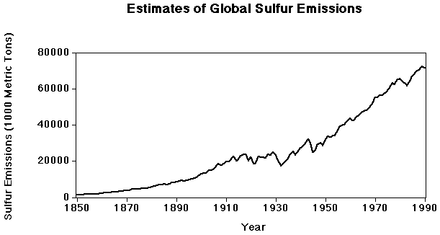

(Courtesy of ASL & Associates, Helena → http://www.asl-associates.com/globals.htm)

Figure 3: Historical Trends in Nitrogen Dioxide Concentration by Year
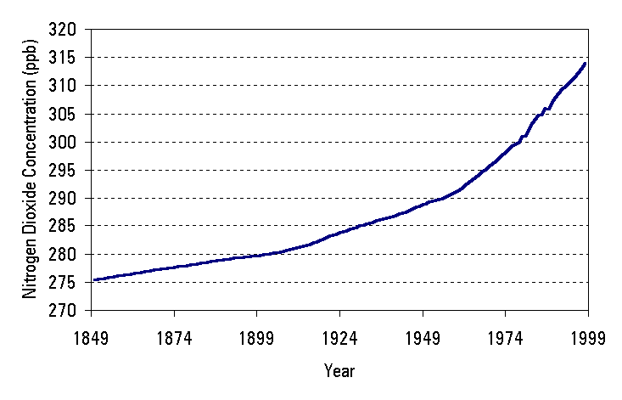

(Source data: NASA Goddard Institute for Space Studies, http://www.giss.nasa.gov/data/si99/ghgases/)

Account for the trends shown in the graphs 5

More space is available for answer to Q18 on the next page.
Space for Question 18 continued
Marks

Question19 5

You performed a first-hand investigation to calculate the ΔH_{c} of some alkanols.

(a) Write a balanced equation for the complete combustion of one mole of 1
1-butanol.

(b) In the space below, draw a fully-labelled diagram of the equipment 2
assembled for use to perform this investigation

Q19 continues on next page.
Question 19 continued
Marks

(c) A student performed the investigation with 1-butanol as a fuel and recorded 2
the following data.

Initial mass of spirit burner = 69.3g
Final mass of spirit burner = 70.1g
Mass of water = 200.0g
Initial temperature of water = 20⁰C
Final temperature of water = 36⁰C

Use the data above to calculate the heat of combustion of butanol in kJmol⁻¹.

Question 20. 6
In the late 1970’s unprecedented and unanticipated depletions of stratospheric
ozone were discovered over the Antarctic and the problem has continued to grow
causing much concern among the scientific community. Scientists are increasingly
blaming the use of CFCs for this depletion of the ozone.

(a) Name a CFC found in the Troposphere and identify its origins. 1

(b) Write equations to show the reactions involving CFC’s and ozone to 2
demonstrate the removal of ozone from the atmosphere.

Q20 continues on next page.
Question 20 continued
Marks

(c) Evaluate the effectiveness of alternative chemicals in use which are 3
replacing CFC’s.

Question 21 4
The following table shows the colour of universal indicator over a range of pH.

pH | 1-4 | 5 | 6 | 7 | 8 | 9 | 10-11
Colour | red | orange | yellow | green | blue | purple | Violet

A student tested four different solutions using universal indicator. The results are
shown in the table below.

Solution | Colour
Sugar | green
Ammonium chloride | orange
sodium hydroxide | violet
potassium acetate | purple

(a) Identify the solution that is the most basic. 1

Q21 continues on next page.

Question 21 continued
Marks
The chart below shows the colour ranges for the indicators methyl orange,
bromothymol blue and phenolphthalein.

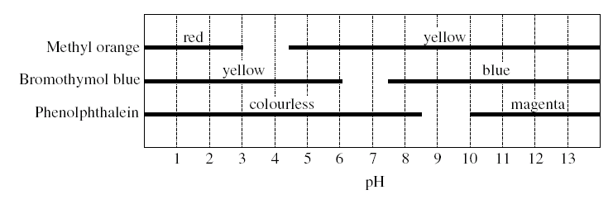

(b) Identify the solution that will be yellow coloured with both methyl orange 1
and bromothymol blue.

(c) Another student wishes to confirm that a solution has a pH of 4. Which of the 2
four indicators should he use? Explain your choice

Question 22 3

The following galvanic cell was constructed.

Ni / Ni²⁺ // Ag⁺ / Ag

(a) Write the anode half equation. 1

(b ) Write the cathode half equation 1

(c) Calculate the E⁰ potential of the above cell. 1

Marks
Question 23. 4

(a) Identify factors that effect the concentrations of a range of ions in solutions 2
in natural bodies of water near farmland.

(b) Describe a method that can be used to monitor possible eutrophication 2
of waterways.

Question 24 (4 marks)
You planned and performed a first-hand investigation to measure the 4
pH of identical concentrations of strong and weak acids.

Justify your choice of acids and the concentrations used for this investigation.

Marks
Question 25
3

Outline the processes that can be used to detect radiation.

Question 26. 7

The Haber process is used to synthesise ammonia gas from nitrogen and hydrogen
gases. The reaction uses a solid catalyst and is operated at about 4000C and 30Mpa.
The percentage yield is about 35% at equilibrium.

N_{2(g)} + 3H_{2(g)} 2NH_{3(g)} ∆H = -92 KJ

(a) Identify an industrial use of Ammonia. 1

(b) Explain why the rate of reaction is increased by higher temperatures. 2

Q26 continues on next page.
Marks
Question 26 continued

(c) Explain how increasing the pressure changes the position of the equilibrium. 2

(d) Identify the catalyst used in the Haber process and explain the effect of using 2
such a catalyst on the yield of ammonia.

Question 27 4
In April 2002, stories circulated in the mass media about Russell Beckett's "magic water". Below is an excerpt taken from an article in the Good Weekend magazine (6th April).

The villain in this story is carbon dioxide. Every person produces half to one kilogram of carbon dioxide a day. It is produced inside body cells as a toxic by-product of the process by which our bodies create the energy to survive. The acids formed from carbon dioxide contribute to fatigue and degeneration and are the building blocks for all inflammatory diseases.

- Write an equation to illustrate the formation of an acid from carbon dioxide. 1

Q27 continues on next page.

Marks
Question 27 continued

The active ingredient in the "magic water" is magnesium bicarbonate (magnesium hydrogen carbonate). The article stated that

"Bicarbonate is the natural buffer against acid in the body."

- Explain, using balanced equations, how the bicarbonate (hydrogen carbonate) 3
buffers against the acid produced in the body. Include mention of Le Chatalier's principle in your answer

Question 28 3
A student prepared a standard solution of sodium carbonate by dissolving 1.208g
of sodium carbonate in distilled water and making the volume up to 250.0mL.
25.0mL aliquots of the sodium carbonate solution were then titrated against
hydrochloric acid of an unknown concentration.

(a) Identify an indicator that would be suitable to use for this titration. 1

(b) Explain why sodium hydroxide was not used to make the primary standard. 2

Marks

Question 29 6

Evaluate the use or potential use of a specific named biopolymer.

END of Section I

